**EMOTION RECOGNITION BY INCLUSION OF AGE AND GENDER PARAMETER BY DEEP LEARNING**

**Adithya Holla K, Aditya Murugan, Akil Raif, Ashwamedh Arote**

Computer Science and Engineering &NMAM Institute of Technology, Nitte Karkala

---------------------------------------------------------------------***---------------------------------------------------------------------

**Abstract -** Due in large part to the expansion of social media and online social networking websites, automatic gender, age, and emotion identification has become more significant, leading to an expansion of its usage in various software and hardware. The commercials could be tailored to the caller's age and gender. In criminal instances, it can also aid in the identification of suspects, or at the very least, it can reduce the number of suspects. DNN known as a CNN is frequently used for NLP and image identification and processing. The model is trained for gender, age, and emotion recognition from photos using a CNN architecture.

***Key Words*:** Emotion detection, Age Detection, Gender Detection, Flask, Ngrok, Convolutional Neural Network

1. **INTRODUCTION**

In the end, facial analysis technologies may transfigure how we live. When combined with artificial intelligence, it can offer personalized support in every area of life. It can gauge our mood at the morning of the day, make connections with our routines, and consider other aspects. It can offer the ideal mess at the right time, best music to accompany with that mess, and the ideal vesture grounded on the cast. The dull aspects of life can be handled by machines. Security and videotape surveillance, electronic client relationship operation, biometrics, electronic dealing machines, mortal- computer commerce, and entertainment.

## Literature Survey

**2.1 Existing Method**

**[1] Facial Emotion Recognition By Using Deep Learning**

They recommended using deep Convolutional Neural Network for FER across available databases. The pictures were resized to 48x48 pixels after the facial landmarks. The employed architecture consists of two layers for convolution pooling, two modules for inception styles, and convolutional layers of 1x1, 3x3, and 5x5.They suggest a brand-new CNN for finding AUs in the face. They use two convolution layers for the network, max pooling for each, and two totally linked layers that show the amount of activated Aus. For the purpose of identifying the crucial facial features .Each of the three CNNs they used to detect a face feature—such as a brow, an eye, or a mouth—had the identical architecture. Cropping and key-point facial detection was performed on the image before they are uploaded to CNN. To recognize facial emotion, a second type of CNN was created and the iconic face obtained in combination with the raw image was used. Researchers have found that this strategy provides more accuracy than using raw photos or only iconizing the face.

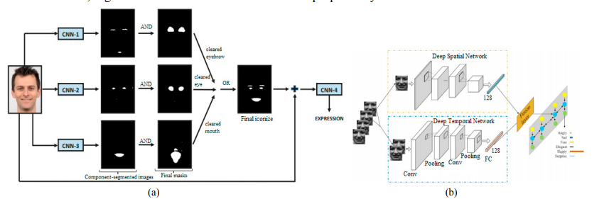

**Fig -1**: Different deep learning methods

.

**[2] DAGER Using CNN (Convolutional Neural Networks):**

Our first deep model is trained to recognize faces using a big dataset of four million photos. Our face trait recognizers are built on top of this model, which is also used to fine-tune networks for four different tasks. Estimating age in real and apparent terms, identifying gender, and recognizing emotions we begin by employing four million photos, unique individuals to train for the job of facial recognition. Our computer for recognizing face traits is built around this approach. We created a deep network armature that has been considerably optimized for each task's speed and delicacy.

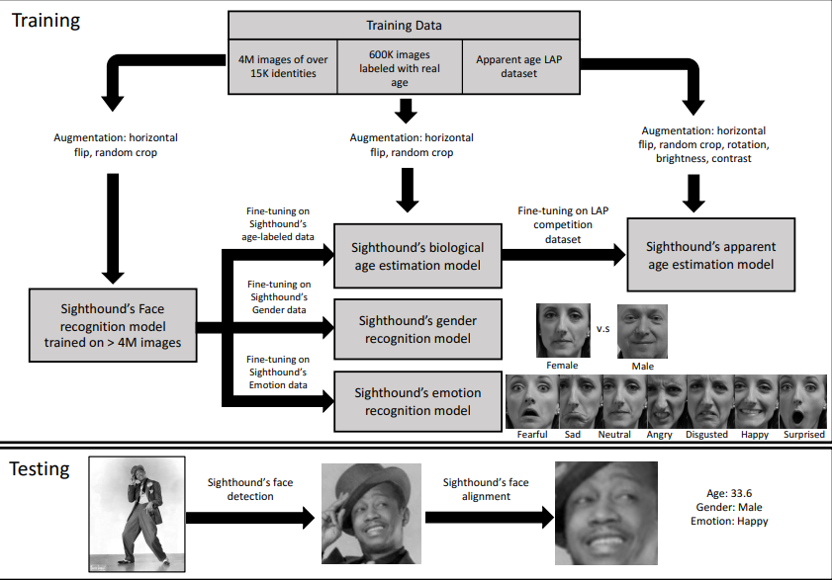

**Fig -2:** pipeline

**[3] Understanding and Comparing Deep Neural Networks  
for Age and Gender Classification**:

Regarding data preprocessing, there are options for training and classification. By including a 3D face frontalization preprocessing step, the SVM-based system from enhances the existing system. In this study, we compare models with random weight initialization to models with initialization based on weights and used for different datasets, specifically the ImageNet data set and the IMDB-WIKI data set. The process is iterative, applying successive layers of inputs and outputs from the model. Calculating relevance scores Ri for hidden units in the interim in a backpropagation process

**[4]FER (Facial Emotion Recognition) Using Deep Convolutional Networks:**

This study's main objective was to build a model based on facial action units (AUs), which CNN first identified and then used to recognize the seven basic emotional states. They used the Cohn-Kanade database and integrated AU to get the best accuracy rate of 97.01, whereas other studies in the literature used a direct CNN and could only manage an accuracy rate of 95.75%.

**[5] Age and Gender Prediction Using Transfer Learning and Deep CNNs**

Prediction accuracy was increased by transfer learning using both the VGG19 and by examining the results of modifications to various design strategies and training parameters, VGGFace pretrained models were created. As a result it shows that using the appropriate model training strategies can result in high accuracy.

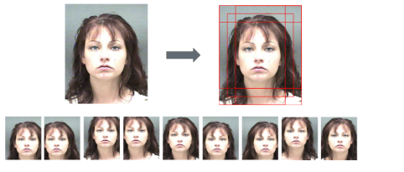**Fig -3:** The images are cropped and flipped to become ten images.

# [6] Cnn Based Detection Of Emotion, Age, Gender

Utilizing three layers of convolution, we normalize the data between 0 and. We employ Max Pooling, RELU activation function, and Batch Normalization for each layer. Loss function is calculated by the Adam optimizer. Save the weights to utilize the trained model later.

**[7] Detection of Gender, Age and Emotion of a Human Image using Facial Features**

They often start by downloading the image collection from the IMDB WIKI dataset because it is the largest publicly accessible dataset with gender and age labels for training. An image set is simultaneously retrieved from a dataset known as FERC-2013.

**[8] SAF- BAGE:**

For saliency prediction and soft-biometric classification, the suggested method employs the pre-trained weights of SALICON and ImageNet, respectively. On a workstation with an Intel Xeon core processor and an NVIDIA Titan 12 GB GPU for acceleration, the fine-tuning is carried out. All tests are conducted using Tensor flow 1.6.

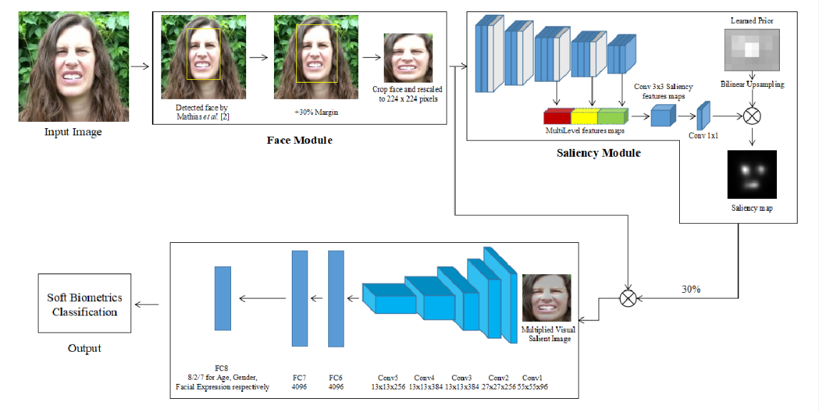

**Fig -4:** Convolution Module

**[9]** **Age, gender, and emotion estimates for face recognition**

They use OpenCV's Haarcascade classifier to obtain the face detector's face position for training and test images. Papageorgiou C. et al. proposed the first Haar features. Then, using the integral image method, Paul Viola and Michal Jones devised a technique for fast calculating Haar features. Later, diagonal characteristics were added to the Haar signature library by Rainer Lienhart and Jochen Maydt. The extended feature library serves as the foundation for OpenCV's Haarcascade classifier.

**[10] Fast Face Emotion Detection Using CNN and Gabor Filters**

According to a different article by Milad Mohammad Taghi Zadeh and colleagues the Gabor filter really takes the image sub feature and delivers it to the neural network. As a result, CNN (convolutional neural network) gathers number of sub features and improves accuracy by percent when extracting emotions from faces.

**2.2 Proposed System**

The project is a web based application that takes people's images as input. The dataset which is used for the model , then loaded in the backend. Emotion model is trained by using the FER2013 dataset. After the model has been trained, the input image gets processed by the CNN. Initially the input image is resized and converted from the colourful RGB image to greyscale. The image after being processed is converted finally into a 1D array. It is then given to the HAAR Cascade Classifier. Haar cascade model is used to detect faces and eyes in an image. Once the faces are identified and extracted, this cropped facial image is passed models to create a prediction. Function for loading the caffe models is written. It returns the variable of both the models. The model then compares the output with the predefined values for emotions, age and gender and predicts the corresponding age, emotion and gender values.

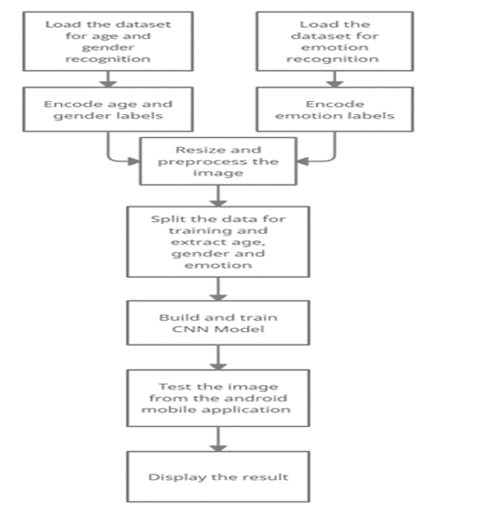

**Fig -5:** Proposed System

* 1. **Challenges**
* Unfortunate web network it very well may be an issue with modem or switch or poor signals.
* Uncouth picture outline the picture caught ought to contain a human face and ought to be adjusted properly. The individual should not be excessively close nor excessively far (an edge like an identification size print would be pertinent).
* Vaticination delicacy-The delicacy of the vaticination is to a great extent reliant upon the casing caught.
* Dynamic URL-The ngrok gives circle liberated from cost however the URL changes with each figure. Accordingly, this URL should be changed in the android activity and the activity must be raised once more
  1. **Implementations Details**

**2.4.1 Working of Age, Gender Prediction**

Bringing in cv2, which is an OpenCV library which has the CNN capacities. Tape is caught utilizing the raised in camera. Information can be changed like usb camera connected. Haar cascade model is utilized to descry faces and eyes in a picture. Recently, the level and scope of the edge is set. Capability for stacking the caffe models is composed. It returns the variable of both the models. These lines were downloaded from the Kaggle site. This framework was presented by two Israel experimenters, Gil Levi and Tal Hassner in 2015. This contains the data of the prepared brain organization (prepared model). Both. Caffe model lines are the model lines. The reasoning lines characterize the layers in the brain organization, each subcaste's bits of feedbacks, works and usefulness. The tape caught is reused progressively to descry the appearances utilizing the Haar cascade

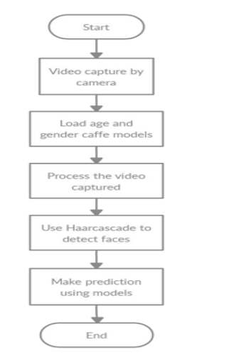

**Fig -6:** Working Of Age Gender Prediction

**2.4.2** **Working of Emotion Prediction**

The FER2013 is used for training the emotion model. The grayscale face images measure 48 by 48 pixels. The photos are equally spaced apart and centered. This dataset comprises of facial emotion categories of anger, contempt, happiness, sadness, and surprise. The dataset has been downloaded. Extract dataset into a data folder with distinct directories. Create the architecture for the convolution network. Compile and train the model, then finish. Model weights should be saved as a ".h5" file. The boxing around the face in the webcam are detected using OpenCV. Haar cascade xml, and emotion is predicted using the trained model.

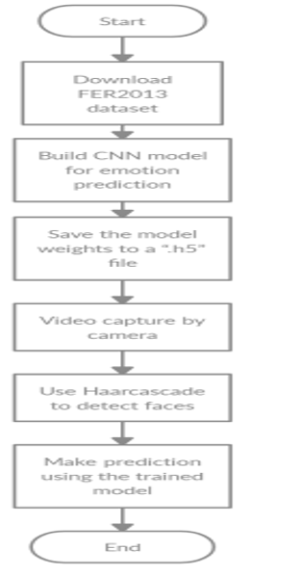

**Fig -7:** Working Of Emotion Prediction

**2.4.3** **Working Of The JavaScript Component Written**

A picture can be chosen or clicked using the upload button. Once the image has been chosen, the "Predict and Suggest" button will appear. Clicking it will cause the computation to be run at the remote workspace, and the predicted outcome will then be shown in the appropriate manner.

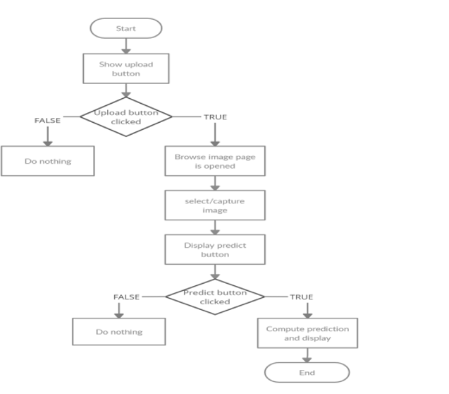

**Fig -8:** Working Of The JavaScript Component Written

**2.4.4 Implementation Of Flask's Web Application**

To render HTML pages and make it possible for the Python code (used to make predictions) to interface with the HTML pages without any issues, the Flask application was developed. The web pages are deployed using NGROK for testing reasons. It is a tunneling reverse proxy that builds safe tunnels between a public endpoint and an active local network service while capturing all traffic for replay and analysis. The upload button possible uses to either pick or click an image after the HTML page has been produced. Once the image has been chosen, the "Predict and Suggest" button will appear. Clicking it will cause the computation to be run at the remote workspace, and the predicted outcome will then be shown in the appropriate manner.

* 1. **Results And Discussions**

Gender, age and emotion recognition has relevant use in various software and hardware. Its use can help provide specialized advertisements that targets the mood of the user. If the user is angry, the website can show advertisements of food or other pleasant activities that calm us down. Further it has more use in employed security measures that are used in airports or banks and even prisons. Criminals can be monitored from their cells. It can predict the emotion of the suspects in the vicinity of the premise which helps in arriving at further conclusions of their actions. A person who has intentions to rob a bank might be scared thinking if he might get caught. By taking the image of him and using the suggested system, it can detect the emotion, gender and age which will help in understanding future Suspects behavior.

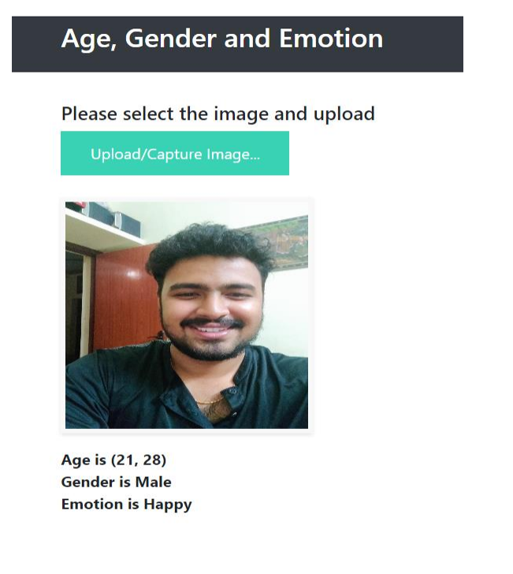**Fig -9:** Displaying Predicted Result

1. **CONCLUSIONS**

The suggested frame has contemporaneous, quick, and effective gender, age, and emotion recognition capabilities. As a result, both a Beaker operation to emplace web operations and an Android operation are created. People from different ethnical groups have varied facial characteristics, which could slightly change the factual age from the awaited age, which can lead to misclassifications. By snooping with the learned features, the use of specs may have an impact on emotion bracket. The sigmoid function was employed by the models in our exploration, but we enforced it far more effectively by replacing it with a ReLU function, which boosts both speed and delicacy. We can observe a sizable enhancement in age and gender discovery delicacy when we differ our design and perpetration with the other executions listed in our exploration. Our programme also mixes gender, age, and emotion to produce results that are specifically acclimatized to each stoner's gender, age, and emotion. Our model's effective delicacy for age, gender, and emotion is 93, 80, and 85, independently. Incipiently, arrival at a performing business service would be interesting. This design is usable to outline culprits and help in catching them either as they're committing the crime or after they've escaped, aside from to customize announcements and content on social media, product rosters in e-commerce, and OTT(over-the-top) content in the entertainment assiduity

**ACKNOWLEDGEMENT**

We don't think our project will be over until we have thanked everyone who has helped make it successful.

First and foremost, we would want to express our deep gratitude to **Dr.** **Niranjan N. Chiplunkar**, our beloved principal, for providing us with the opportunity to complete our project work at our college and all the necessary resources. We sincerely appreciate and owe **Dr. Jyothi Shetty**, professor and head of the department of computer science and engineering, for her inspirational leadership, ongoing support, and helpful suggestions for our project's progress. We want to thank **Mr**. **Raju K,** the project coordinator, and **Mrs. Joylin Priya Pinto,** the project guide, for their unwavering support. We also want to express our gratitude to everyone who has helped us along the course of our endeavor. Finally, we thank the staff members of the Department of Computer Science and Engineering and all our friends for their honest opinions and suggestions throughout the course of our project.

**REFERENCES**

1. Atanassov and D. Pilev, "Pre-trained Deep Learning Models for Facial Emotions Recognition," 2020 International Conference Automatics and Informatics (ICAI), 2020, pp. 1-6, doi: 10.1109/ICAI50593.2020.9311334.

2. I. Lasri, A. R. Solh and M. E. Belkacemi, "Facial Emotion Recognition of Students using Convolutional Neural Network," 2019 Third International Conference on Emotion Recognition By Inclusion Of Age And Gender Parameter By Deep Learning Intelligent Computing in Data Sciences (ICDS), 2019, pp. 1-6, doi: 10.1109/ICDS47004.2019.8942386.

3. Ko, Byoung C. 2018. "A Brief Review of Facial Emotion Recognition Based on Visual Information" Sensors 18, no. 2: 401.

4. M. M. Taghi Zadeh, M. Imani and B. Majidi, "Fast Facial emotion recognition Using Convolutional Neural Networks and Gabor Filters," 2019 5th Conference on Knowledge Based Engineering and Innovation (KBEI), 2019, pp. 577-581, doi: 10.1109/KBEI.2019.8734943.

5. M. Mohammadpour, H. Khaliliardali, S. M. R. Hashemi and M. M. AlyanNezhadi, "Facial emotion recognition using deep convolutional networks," 2017 IEEE 4th International Conference on Knowledge-Based Engineering and Innovation (KBEI), 2017, pp. 0017-0021, doi: 10.1109/KBEI.2017.8324974.

|  |  |
| --- | --- |
|  |  |